**1. Explain the advantages of Natural Queries in PowerBi with an example?**

**Ans:**

**Natural language querying** is designed to simplify the user interface in business intelligence applications. It enables both BI professionals and business users to generate queries and explore analytics data in natural language, using voice or text. Early implementations are focused mainly on enabling a larger number of employees to get information on common business metrics.

As natural language query technology matures, the process could be enhanced with AI guidance for improved insight, as well as natural language processing (NLP) techniques applied to back-end data analysis like conversational analytics and sentiment analysis. Conversational analytics evaluates customer service or employee-to-employee interactions, while sentiment analysis can help summarize consumer opinion from social media, emails and surveys.

Some advantages of using natural language querying tools include the following capabilities:

1. Simplifying employee access to BI data
2. Driving deeper business insights
3. Reducing confusion about analytics results
4. Applying structure to unstructured data

**2. Explain Web Front End(WFE) cluster from Power BI Service Architecture?**

**Ans:**

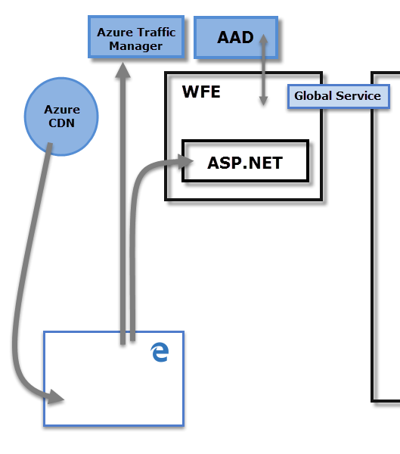

The WFE cluster uses Azure AD to authenticate clients, and provide tokens for subsequent client connections to the Power BI service. Power BI uses the Azure Traffic Manager (Traffic Manager) to direct user traffic to the nearest datacenter. Traffic Manager directs requests using the DNS record of the client attempting to connect, authenticate, and to download static content and files. Power BI uses the Azure Content Delivery Network (CDN) to efficiently distribute the necessary static content and files to users based on geographical locale.

**3. Explain Back End cluster from Power BI Service Architecture?**

**Ans:**

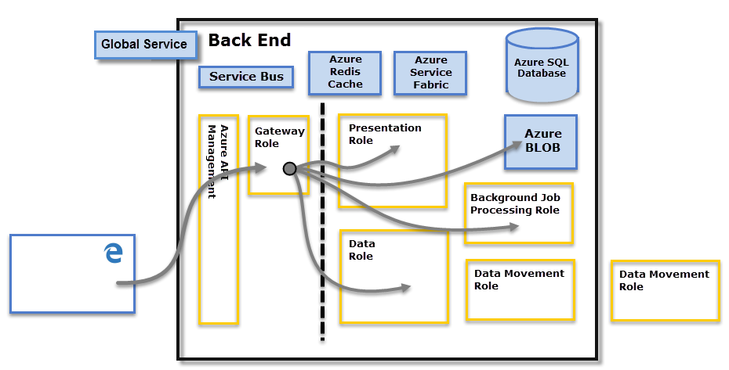

The Back-End cluster determines how authenticated clients interact with the Power BI service. The Back-End cluster manages visualizations, user dashboards, datasets, reports, data storage, data connections, data refresh, and other aspects of interacting with the Power BI service. The Gateway Role acts as a gateway between user requests and the Power BI service. Users don't interact directly with any roles other than the Gateway Role. Azure API Management eventually handles the Gateway Role.

**4. What ASP.NET component does in Power BI Service Architecture?**

**Ans:**

1. ASP.NET is a free-web framework for building great websites and web applications using HTML, CSS and JavaScript.
2. ASP.NET component within Web Front End cluster parses the token to determine which organization the user belongs to and then consults the PBI global service.
3. The Web Front End specifies to the browser which back-end cluster houses the organization’s tenant.

**5. Compare Microsoft Excel and PowerBi Desktop on the following features:**

Data import

Data transformation

Modeling

Reporting

Server Deployment

Convert Models

Cost

**Ans:**

1. DATA IMPORT –

* Microsoft Excel get data from almost everywhere with power query is limited.
* Power-BI also uses power query so it too can get data from almost anywhere.

1. DATA TRANSFORMATION –

* Microsoft Excel is not efficient in handling big data and only handles certain amount of information. * Power-BI can connect a large number of data sources. So, it is very much faster in transform information into insights.

1. DATA MODELLING –

* Microsoft Excel is an ability to work on simple and structured data models.
* Power-BI is an ideal for building complex data models easily.

1. DATA REPORTING–

* Microsoft Excel is an ideal for creating reports in tabular format. So, it creates simple and less attractive reports than those of Power-BI.
* Power-BI is creating tabular reports is more limited. So, it creates more Beautiful, Personalized, Attractive and Interactive reports which can present in dashboard.

1. SERVER DEPLOYMENT –

* Microsoft Excel is On-Premises or hosted cloud.
* Power-BI is a cloud service.

1. COVERT MODELS –

* Microsoft Excel is total focused on structure and simple data models with wide range of features.
* Power-BI is really focused on data ingest and building potentially data model easily.

1. COST –

* Microsoft Excel, most of us already have Excel. So, there is no additional cost for using it to build and share dashboards.
* Power-BI, free for personal use, otherwise US$10/month to share reports with others. For large companies there is a premium licence available.

**6. List 20 data sources supported by Power Bi desktop.**

**Ans:**

1. All

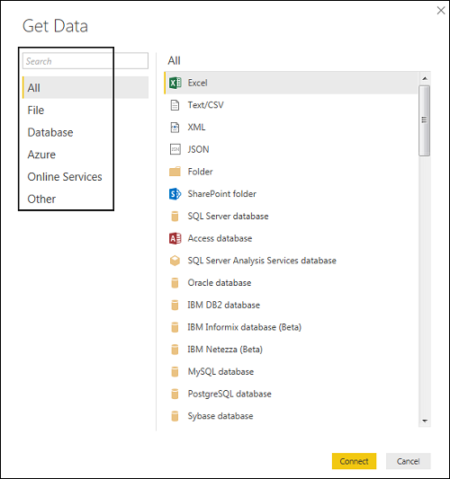

1. File

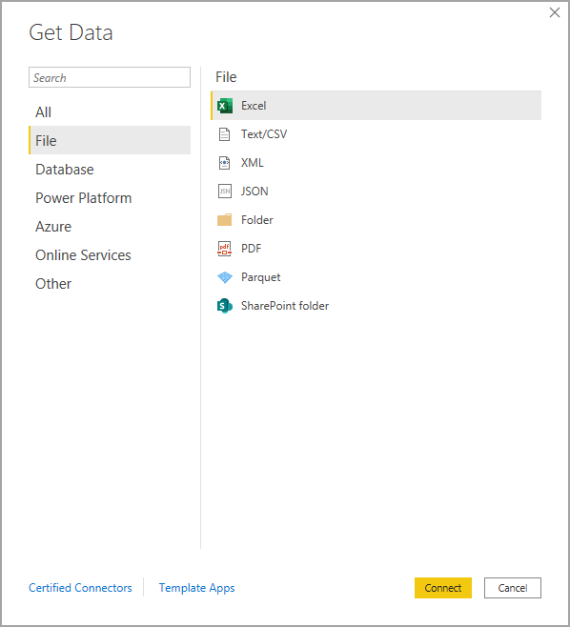

1. Database

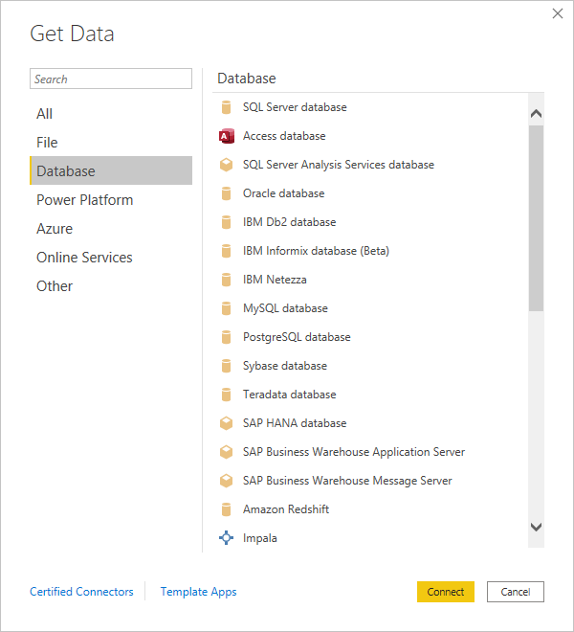

1. Power Platform

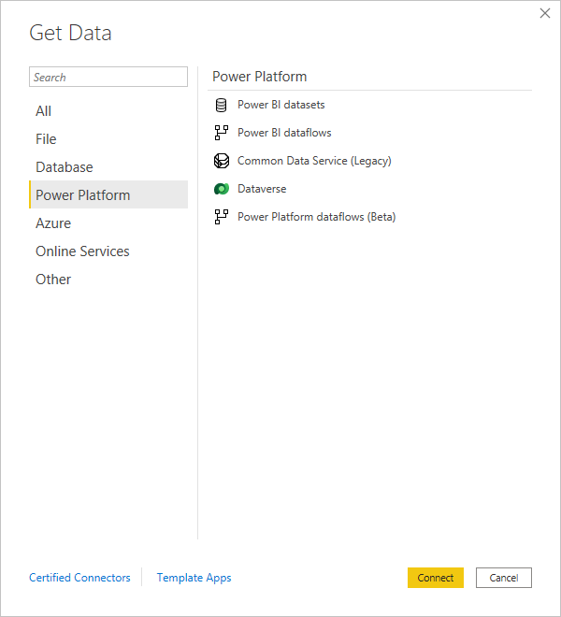

1. Azure

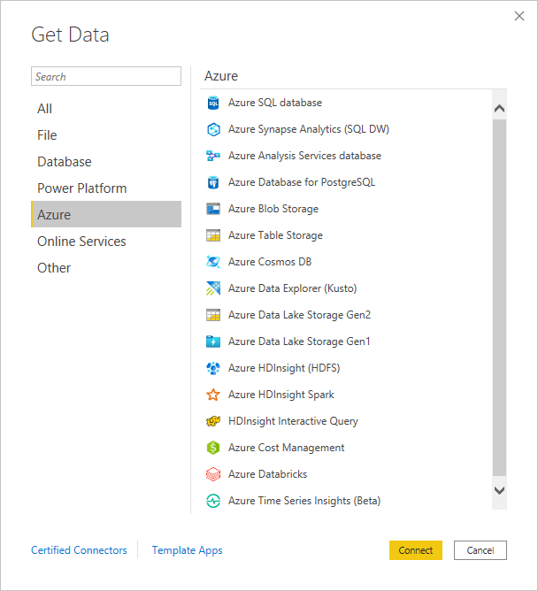

1. Online Services

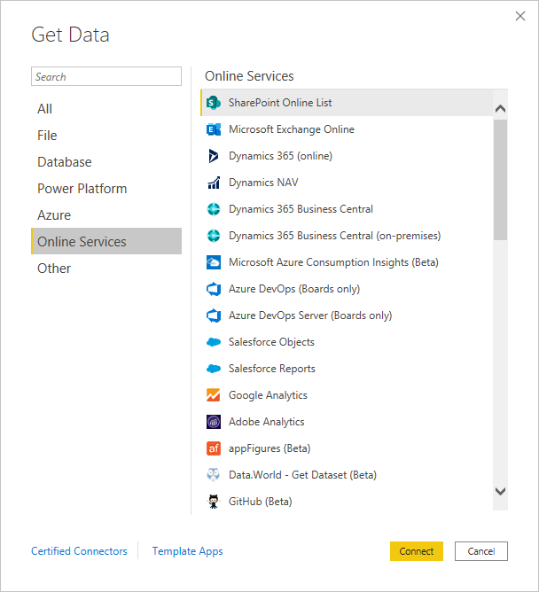

1. Other

